**ADVANCE EXCEL ASSIGNMENT – 12**

**Dataset:**

**https://docs.google.com/spreadsheets/d/1IRSEnmgz8Ro276GslknRNk0zlrB5CZH1YrnT71kqFM/edit?usp=sharing**

**Use the above dataset and answer the following questions.**

**1. What is the total amount of stationary bought from Madhya Pradesh?**

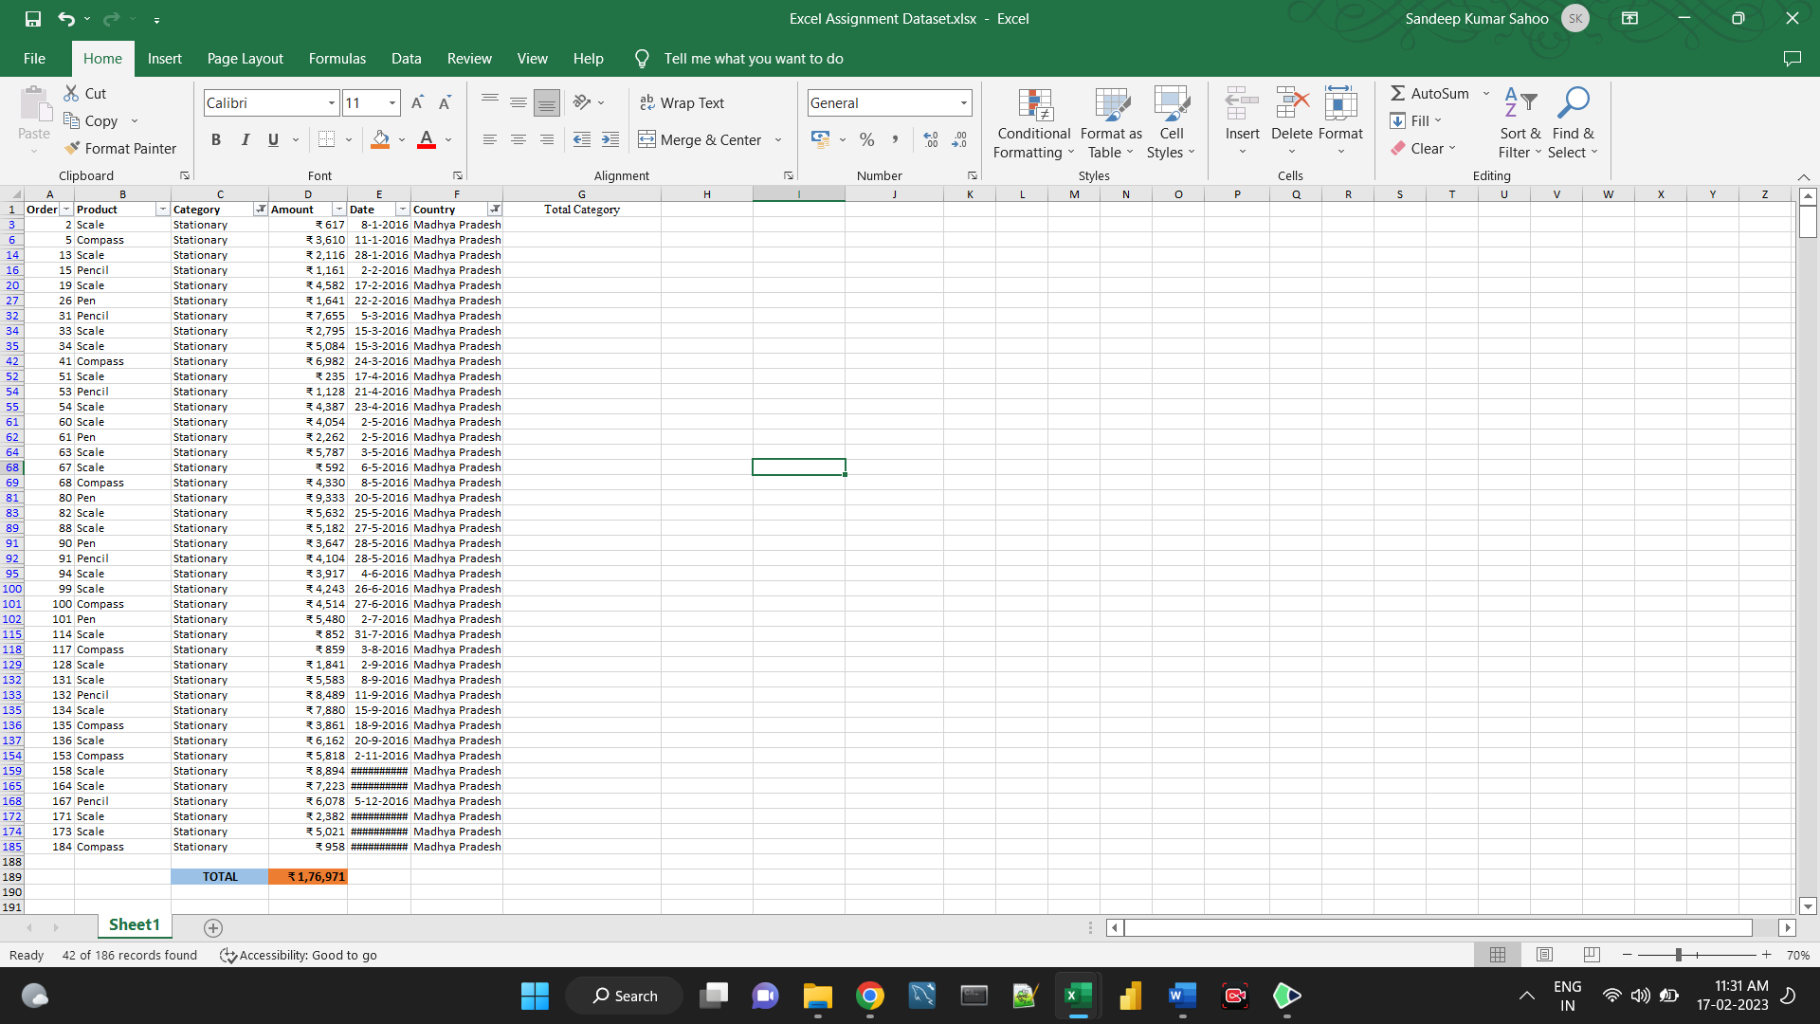

**2. What is the total count of stationary bought from Tamilnadu?**

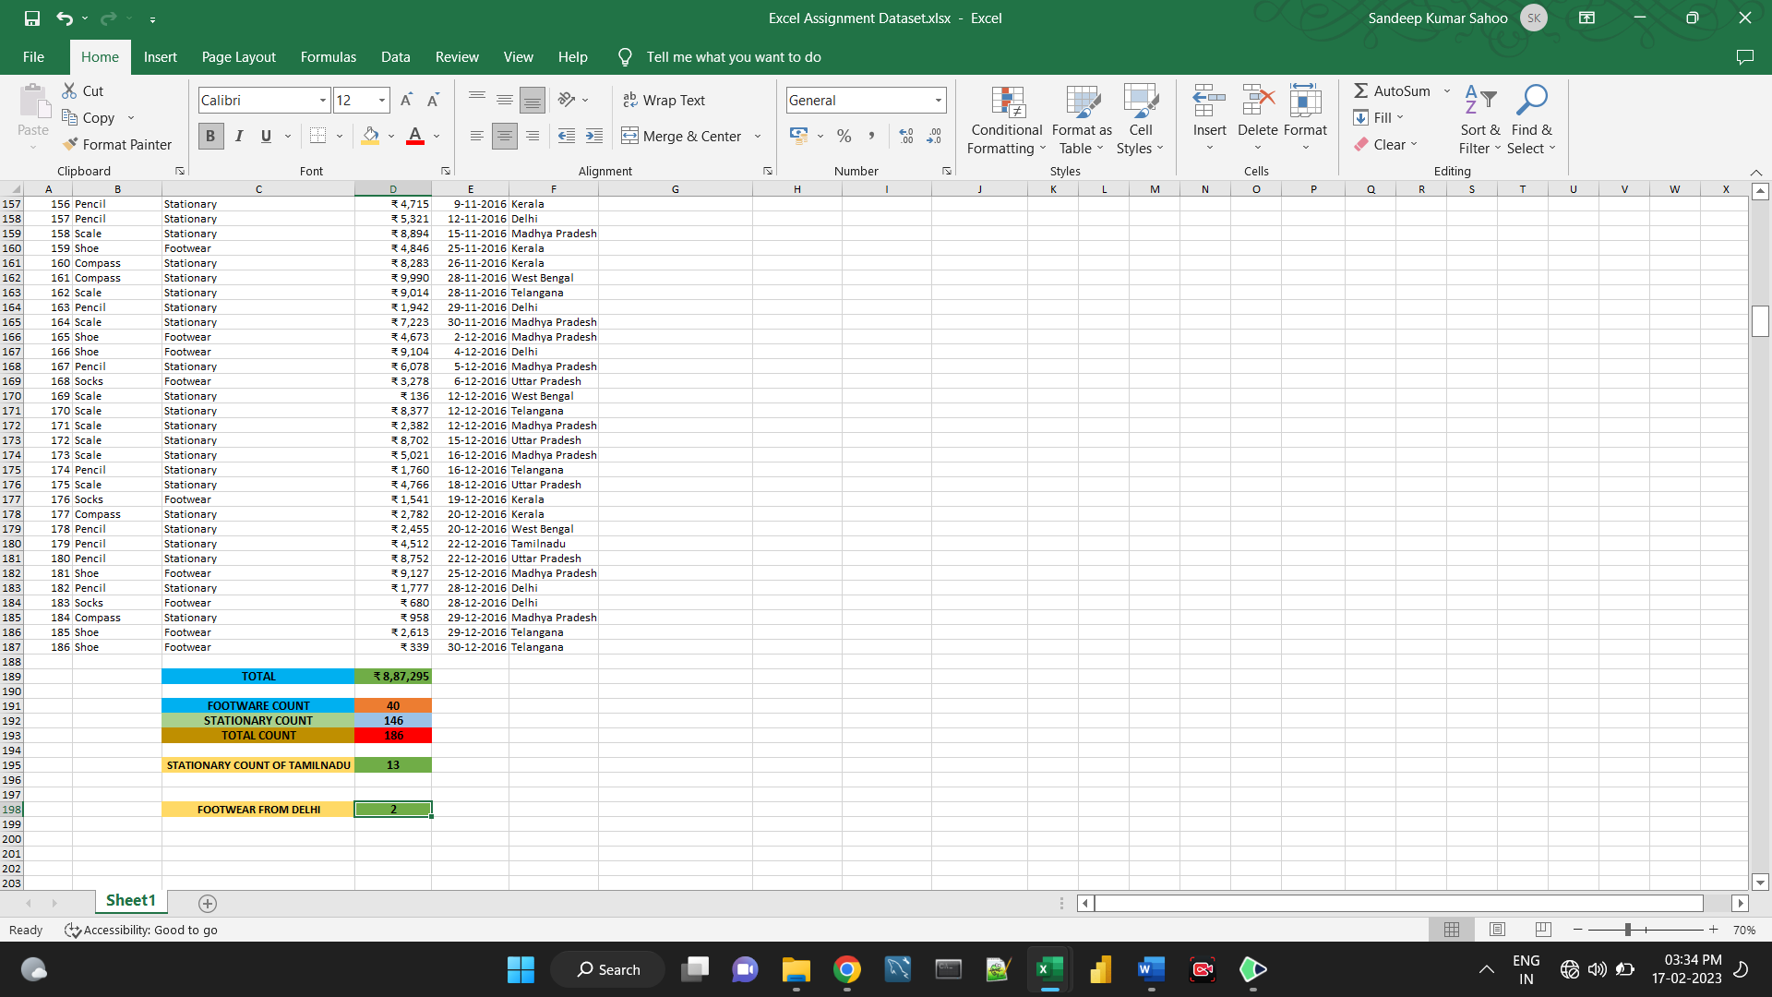

**3. What is the total amount spent on footwear?**

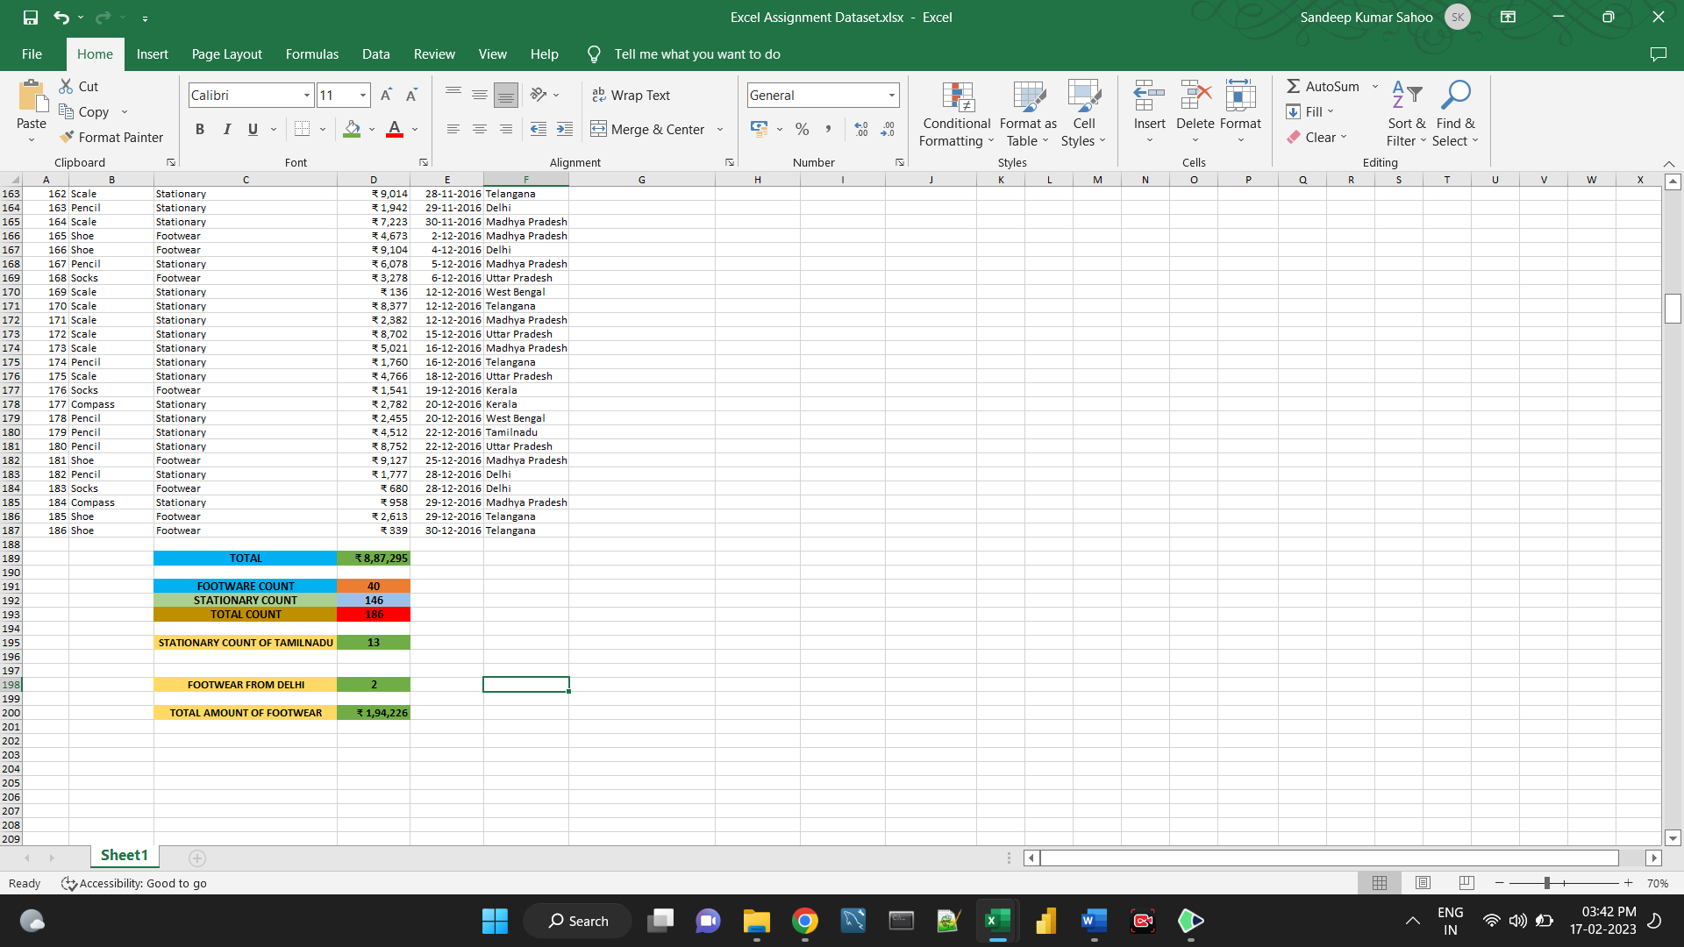

**4. What is the total amount of money spent for stationary in July?**

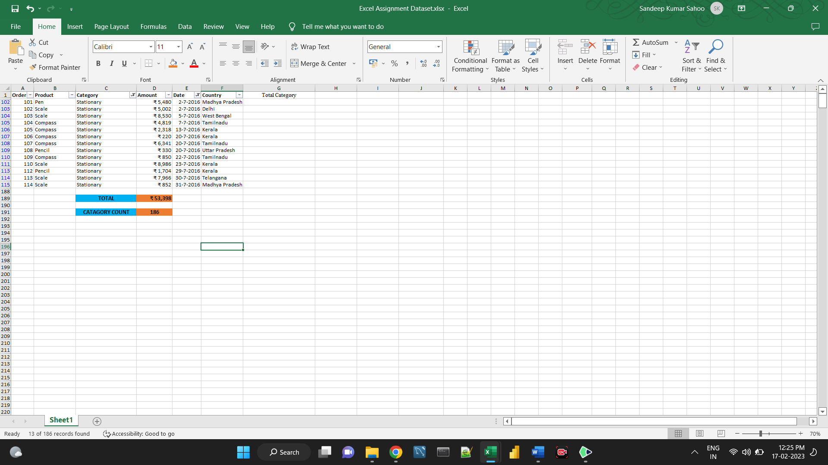

**5. What is the count of footwear that is coming from Delhi?**

